Client / Owner: | Hamilton Wentworth Catholic District School Board
Contractor: |  | Atlantic Roofers Ontario Ltd.
Project Materials observed onsite: |  | SECUROCK Gypsum-Fiber Roof Board by CGC/USG, Dekfast System ES #12 DP Steel 1-5/8” screws w/ 3” Round Galvalume plates E-Coat Black, SOPRAFLASH STICK DUO membrane by Soprema (vapour retarder), SOPRAPLY FLAM STICK membrane by Soprema (vapour retarder flashing), ELASTOCOL STICK primer by Soprema, SOPRAMASTIC by Soprema, Tapered insulation from ACCU-PLANE

Pretium was on site to review the progression of work. Only items observed by the reviewer and reported herein have been reviewed. Other conditions may be present that were not apparent to the reviewer at the time of the visit. The following was observed / discussed:
OBSERVATIONS / COMMENTS
- General
  - Original Estimated Project Completion Date: August 16, 2024 (weather permitting)
  - Projected Completion Date: Currently on schedule
NOT IN CONTRACT
CONTRACTOR STAGING/PARKING
ACTIVE WORK AREA AT TIME OF VISIT
COMPLETE TO NEW CAP SHEET MEMBRABRANE
COMPLETE TO NEW BASE SHEET MEMBRANE
COMPLETE TO NEW VAPOUR RETARDER
KEY PLAN


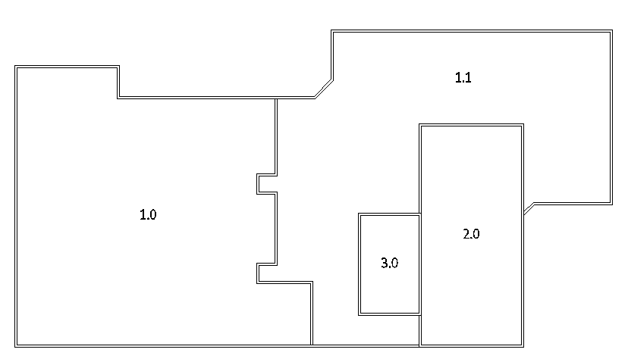
- Site / Staging Area
- Damaged asphalt was observed at multiple locations in the main parking lot on the north (front) side of the school in the area where the vacuum truck and associated bins were parked. | 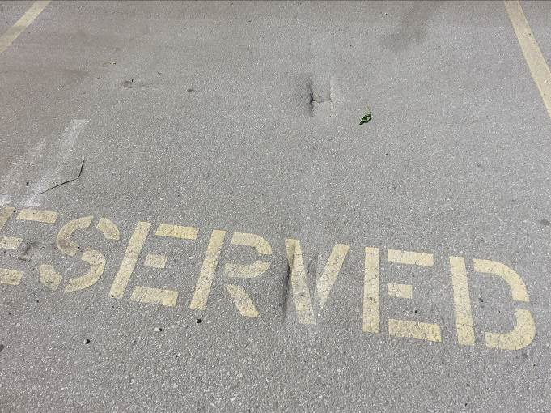
- Damaged asphalt in main parking lot on the north (front) side of the school in the area where the vacuum truck and associated bins were parked. | 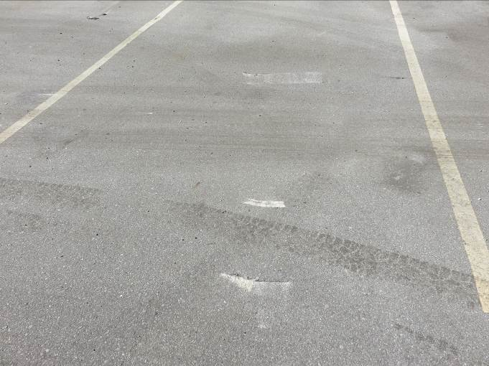
- Damaged asphalt in main parking lot on the north (front) side of the school in the area where the vacuum truck and associated bins were parked. | 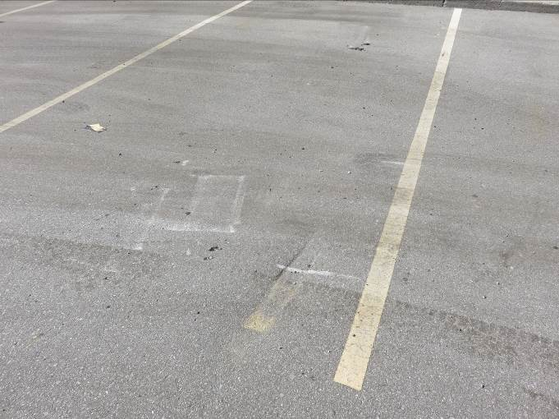
- Staging area has been established in the main parking lot on the north (front) side of the school as discussed during the 2024-06-07 preconstruction meeting. Area has been secured with temporary fencing and disposal bins are within the area. Plywood protection was observed under the bins. Temporary washroom is adjacent to staging area. | 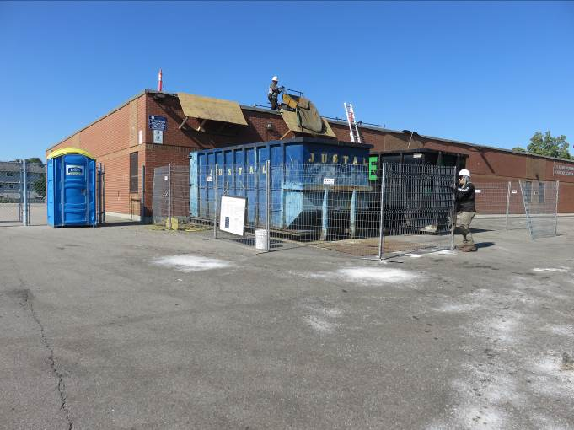
- Significant staining was observed on the asphalt immediately north of the staging area | 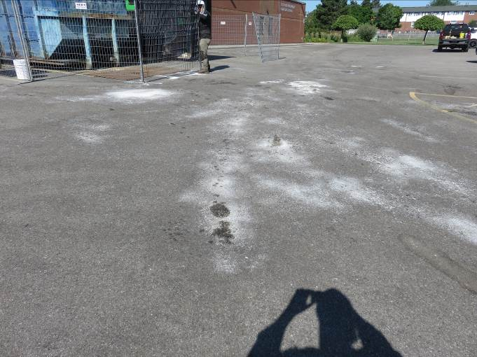
- Damaged asphalt was observed at the south (back) side of the school in the paved playground area where a disposal bin was previously located. | 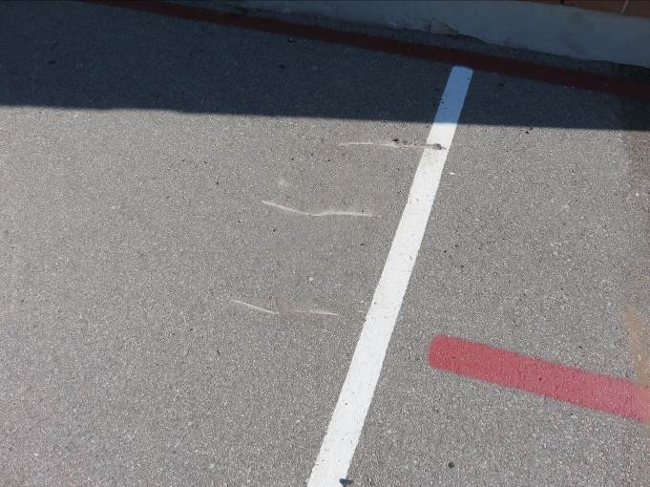

- All Roof Sections
- Gravel surface has been removed/vacuumed from all roof sections and vacuum truck and associated bins have demobilized from site.  Foreman advised it is the intent to tear-off existing on all roof sections and install new deck overlay board and vapour retarder throughout prior to installing new insulation and membrane. | 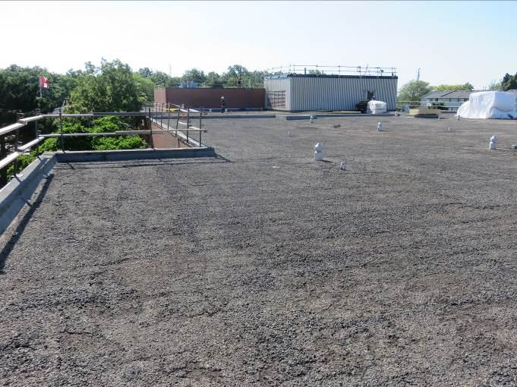
- Roof Section 2.0 (Gymnasium)
- Tear-off of the existing assembly was in progress at the time of visit at the central portion (approx. 40%) of the area.  Foreman was reminded to document any/all missing or damaged acoustic insulation in the deck flutes requiring replacement. | 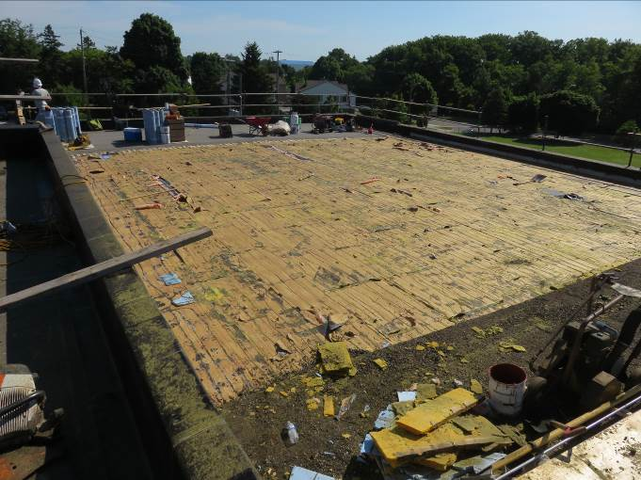
- Foreman advised both drainpipes within the tear-off area broke when the existing drains were removed due to significant corrosion of the pipes.  Pretium confirmed with HWCDSB that Contractor to use own subtrade as required to make needed repairs so the roof can be made watertight and still drain so the structure isn’t overloaded. | 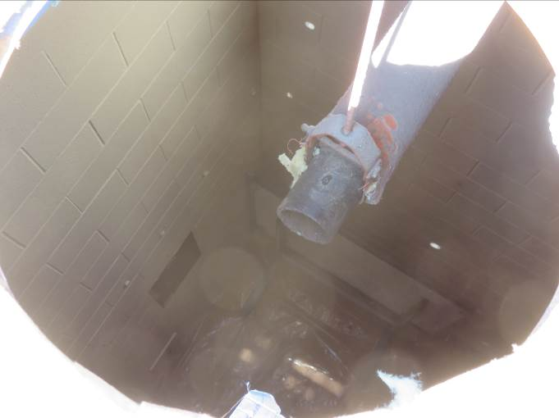
- Pretium and Foreman reviewed high wall detail to determine if existing cladding needs to be cut back. Current distance from top of deck to bottom of cladding is approx. 12”. Pretium advised 8” from top of finished roof to bottom of cladding is recommended but will accept 7”. If distance between finished roof and bottom of cladding is less than 7” then cladding is to be cut back so new membrane flashings can extend 8” above finished roof. New membrane flashings are to be tucked up behind cladding. Foreman agreed. | 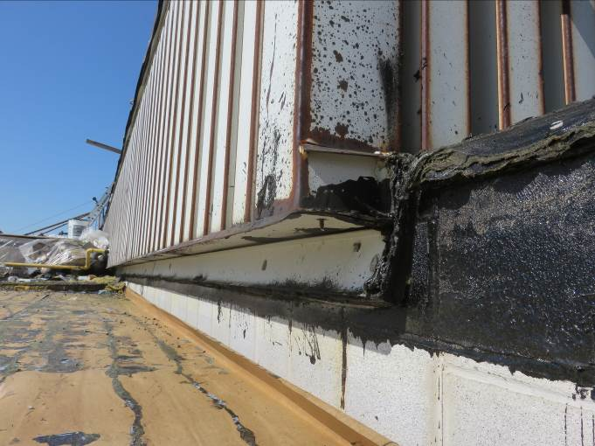

- Roof Section 3.0 (Mechanical Penthouse)
- Section is completed up to new vapour retarder. | 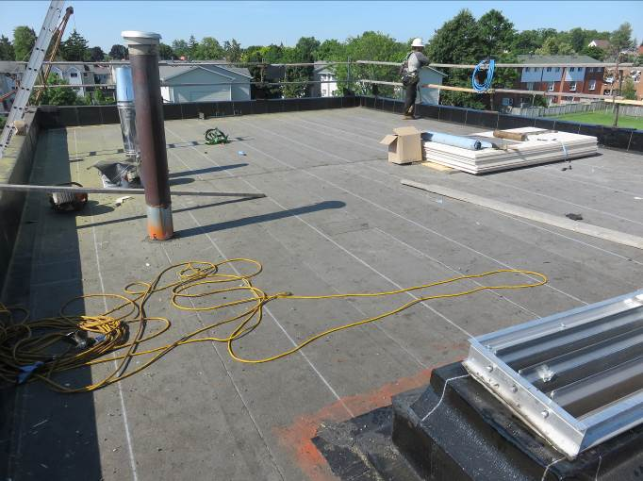
- Pretium and Foreman reviewed new wood blocking at louvre curb. Pretium requested a new metal skirt be installed on the interior face of the curb covering all exposed wood and extending down a min. 1” onto the existing metal liner prior to the louvre being resecured to the curb. Foreman agreed. | 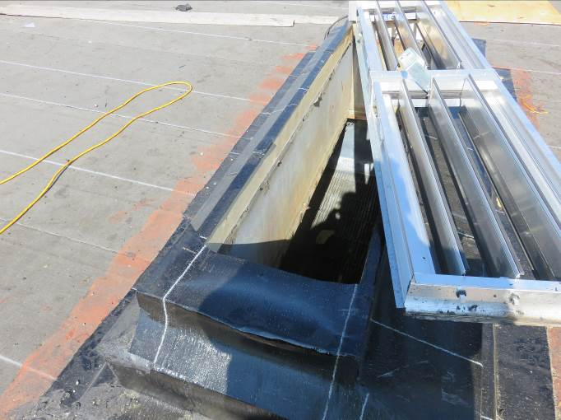

This report was issued to all parties on November 7, 2026.
Trade foreman was verbally notified of report contents. This report pertains to work specifically requested and comments only on operations and items that were visible or being undertaken at the time of our inspection.
Report by: | Dave Neal. H.Dipl.T., RRO

